Task 1 Progress – Genome-wide Identification of Salt-Stress Responsive Proteins (Fagopyrum esculentum)

Step 1: Genome Selection
Explored NCBI and Kazusa BGDB for the buckwheat (Fagopyrum esculentum) genome.
Selected the latest scaffold-level assembly with high quality.

Step 2: Genome File Download
Downloaded the predicted protein FASTA sequences from the selected genome.
No GFF/CDS files were available; the GBFF file was present.
Decided to proceed with the protein FASTA sequences as the main input for homology search.

Step 3: Preparing BLAST Query
Selected AtSOS1 (Arabidopsis salt-stress protein) as the query protein.
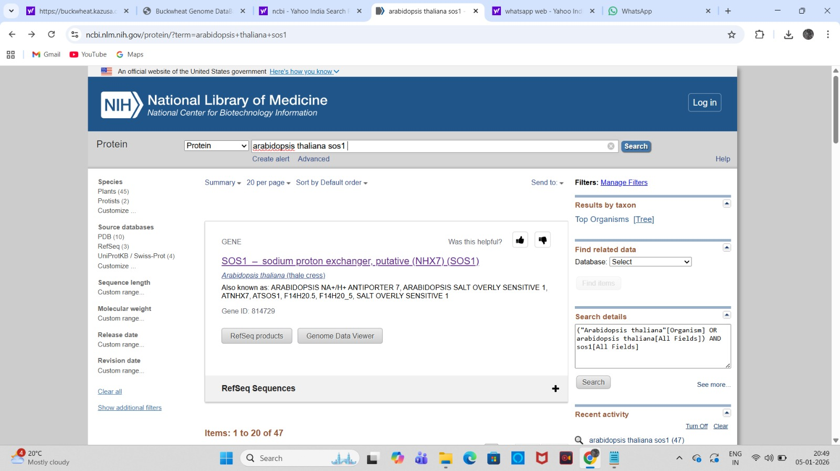
Copied its FASTA sequence into the Kazusa BGDB BLASTp query box.
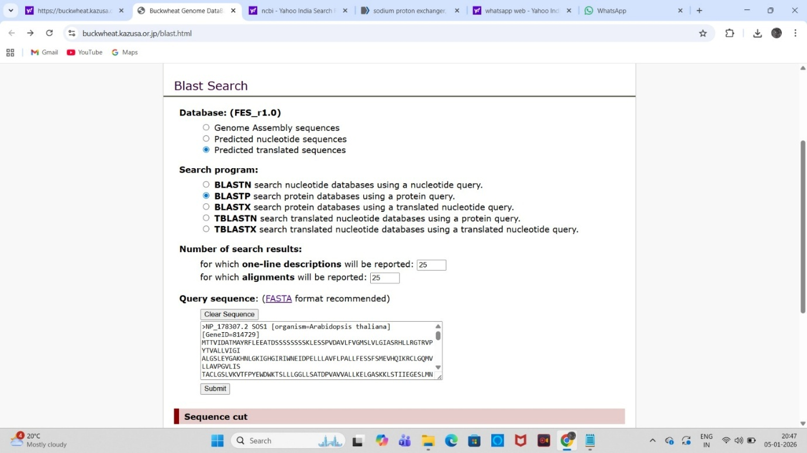

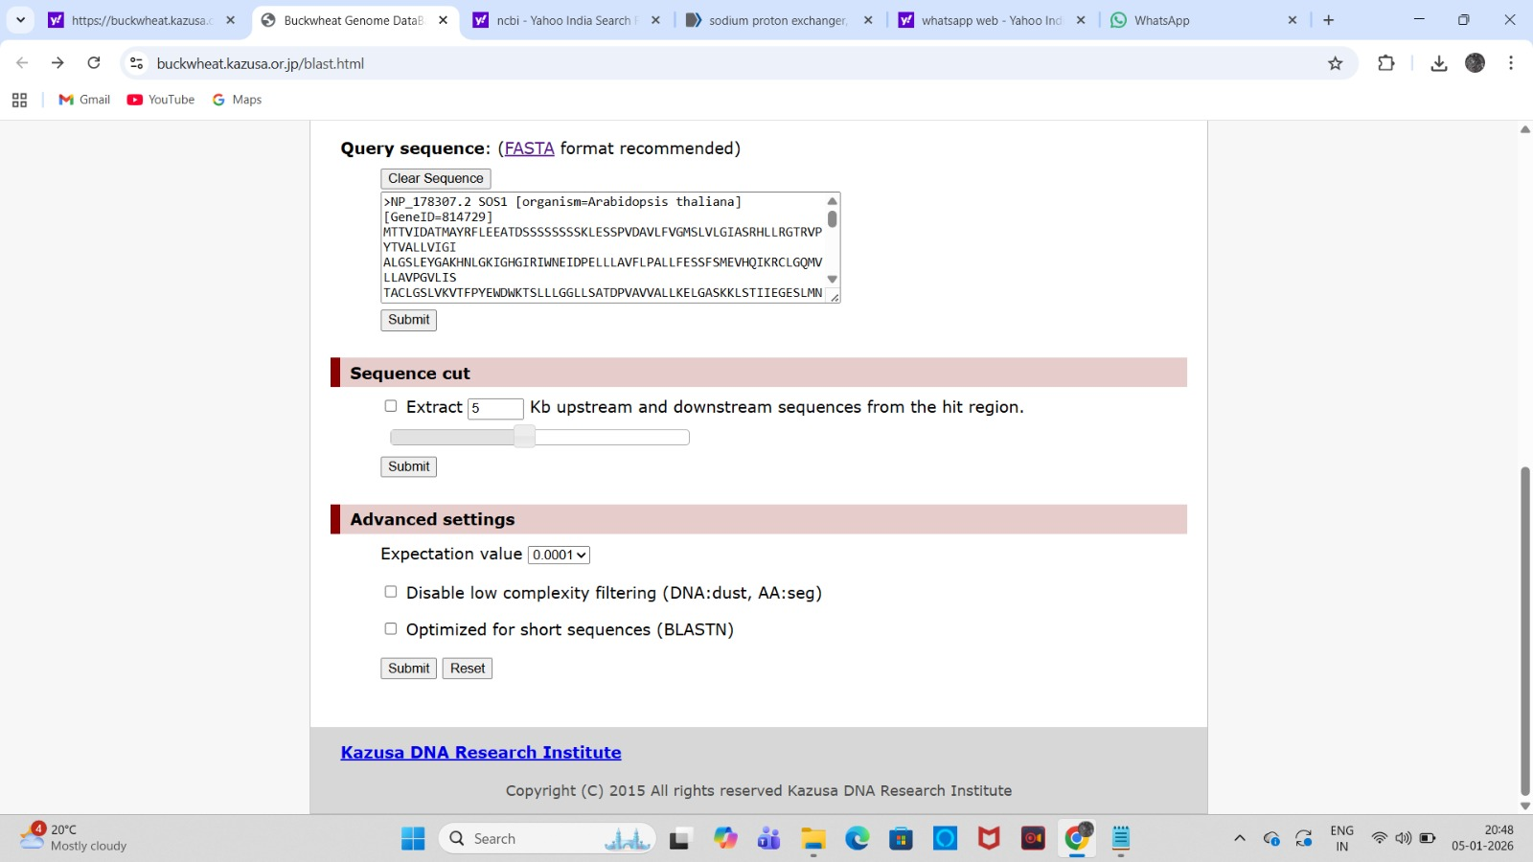

BLAST parameters:
Database: Predicted translated sequences from buckwheat
E-value threshold: 0.0001
Low-complexity filtering: ON
Short-sequence optimization: OFF
Max target sequences: 25
Output format: FASTA + JSONL/TSV

Step 4: BLAST Execution
Ran BLASTp successfully.
Obtained a list of hits with:
Subject IDs (buckwheat proteins)
% identity
E-value
Alignment length

Step 5: BLASTp Homology Identification(SOS1)
Genome Retrieval:
The buckwheat (Fagopyrum esculentum) genome and predicted proteome (286,768 protein sequences, total 70,713,894 amino acids) were retrieved from the Kazusa Buckwheat Genome Database (FES 1.0.pep).
BLASTp Query Preparation:
Arabidopsis SOS1 protein (NP_178307.2, 1146 aa) was used as the query.
The protein FASTA sequence was copied into the Kazusa BGDB BLASTp tool.
BLASTp Results Filtering:
Hits were filtered using an E-value ≤1e-4 and sequence identity ≥40%.
Only hits meeting these criteria were considered high-confidence homologs.

Current Findings:
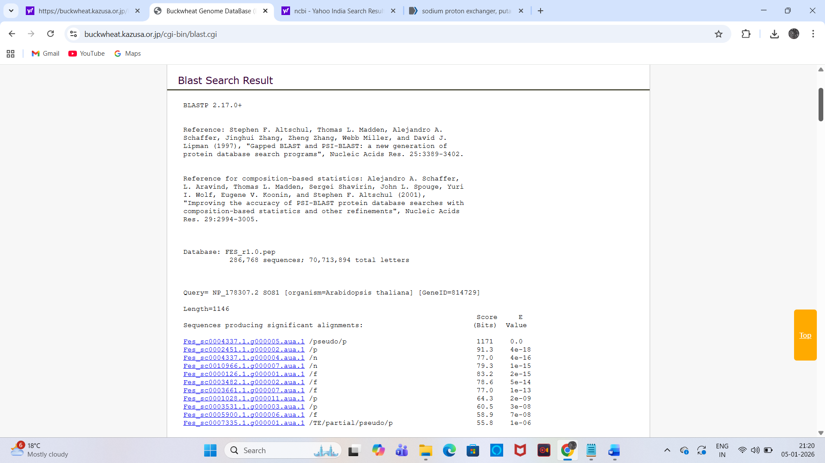
Confirmed SOS1 Homolog: Fes_sc0004337.1.0000005.aua.1 (60% identity, E-value 0.0).
Annotated as Na⁺/H⁺ exchanger. Belongs to ion transporter family.
Other Hits: Below identity threshold (<30%), excluded as distant transporter-like proteins.

Step 6 (SOS2): The Arabidopsis protein used as the query is AAF62923.1, which is the serine/threonine protein kinase SOS2.

BLASTp Homology Identification (SOS2)
Genome Retrieval:
The buckwheat (Fagopyrum esculentum) genome and predicted proteome (286,768 protein sequences, total 70,713,894 amino acids) were retrieved from the Kazusa Buckwheat Genome Database (FES 21.0.pep).
BLASTP Query Preparation:
Arabidopsis SOS2 protein (AAF62923.1, 446 aa) was used as the query sequence.
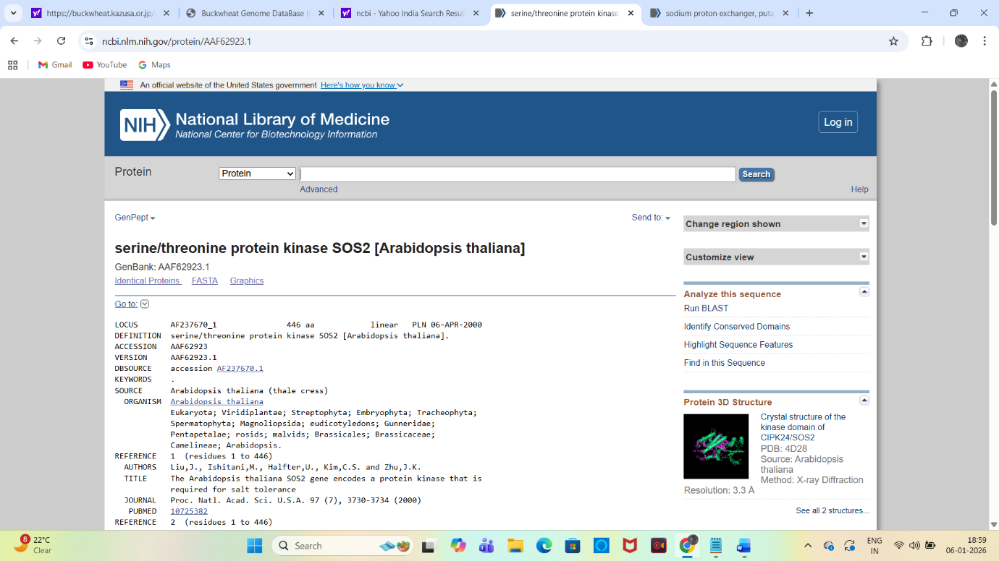
The protein FASTA sequence was copied into the Kazusa BGDB BLASTP tool.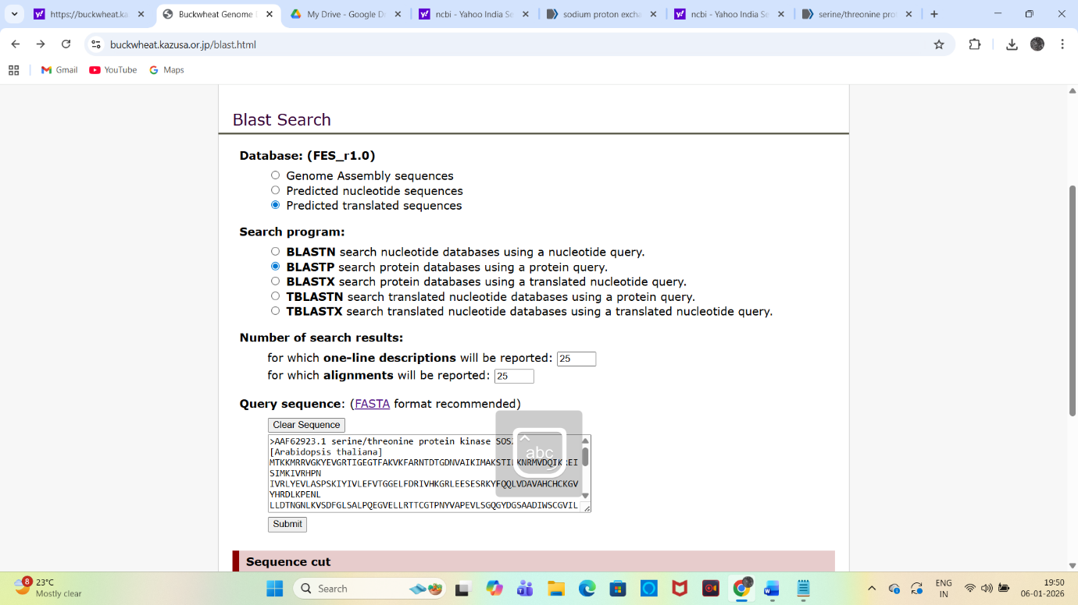
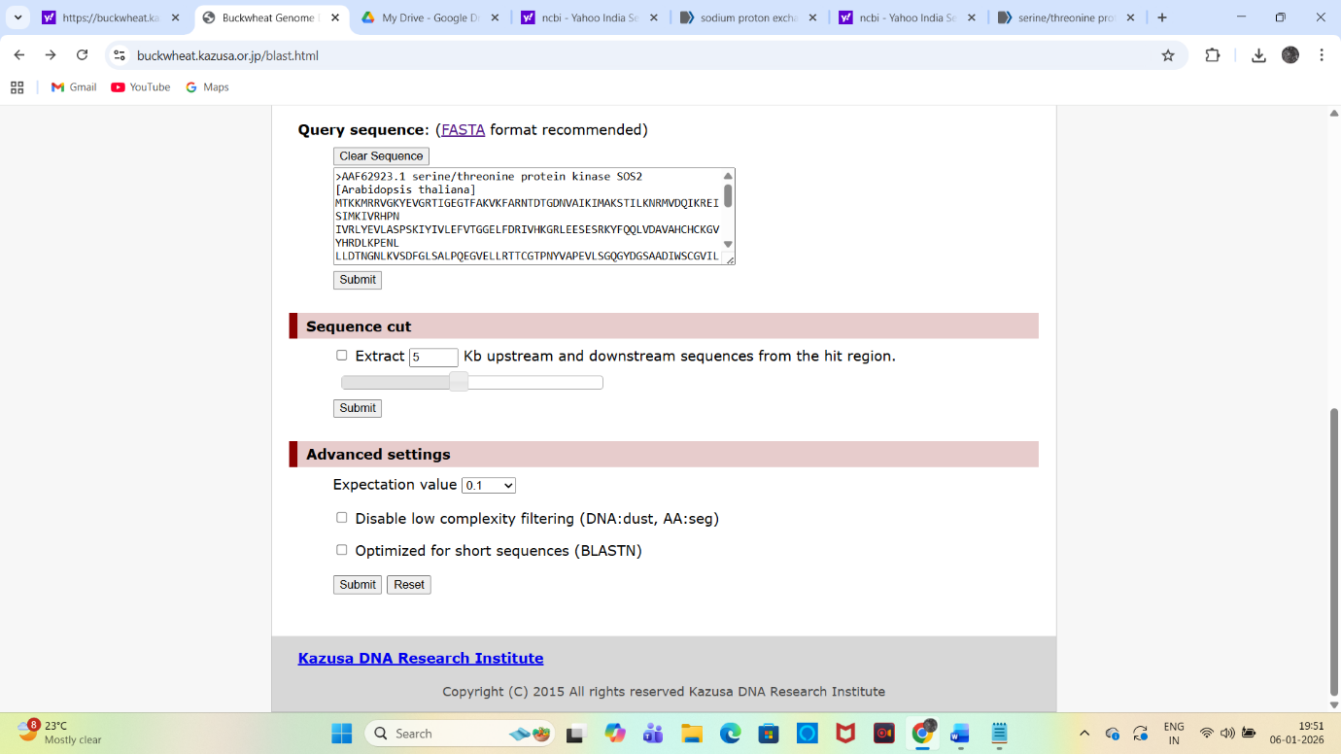

Current Findings (Top SOS2 Homologs):
Six high-confidence SOS2 homologs were identified in buckwheat
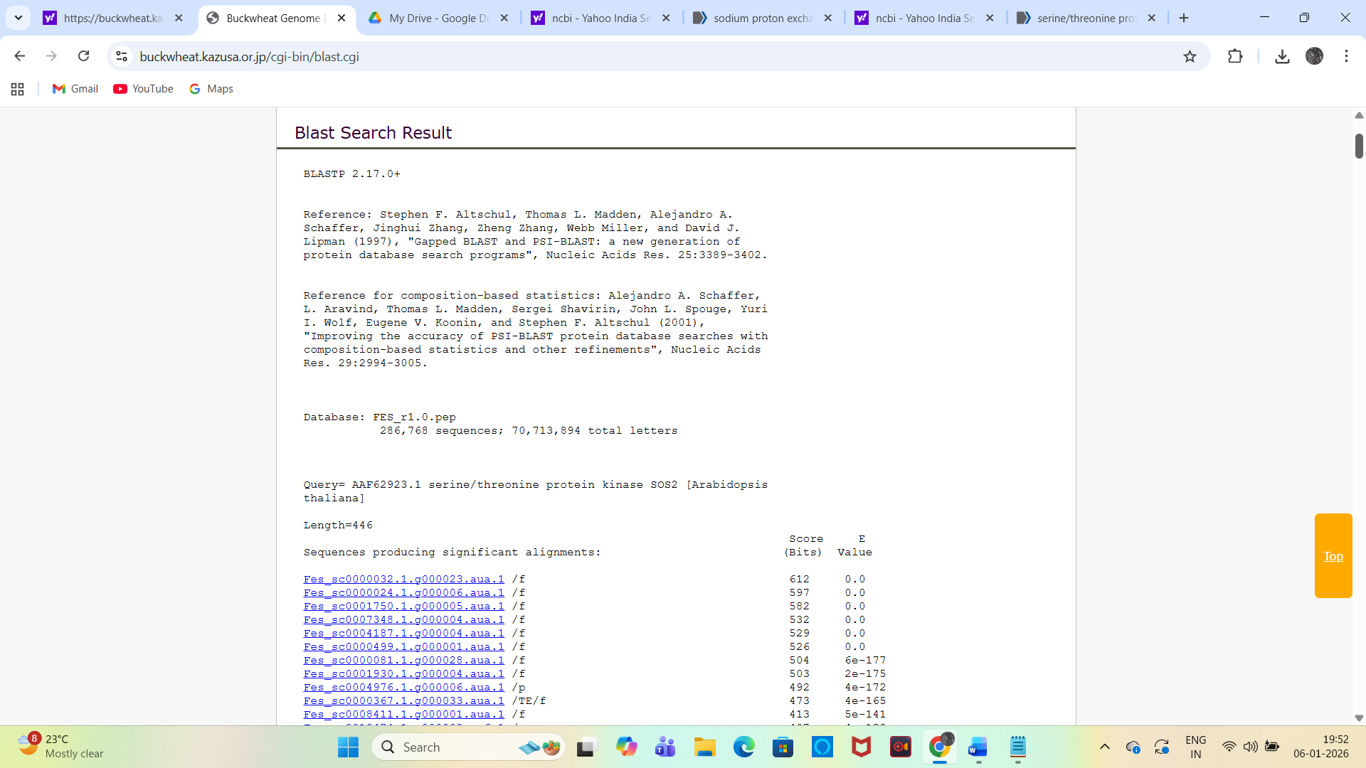
Among these, Fes_sc0000032.1.9000023.aua.1 exhibited the highest sequence identity (69%) and full-length alignment (436 aa) with Arabidopsis SOS2 and was therefore designated as the canonical SOS2 homolog in buckwheat.
Hits below 40% identity or E-value >1e-4 were excluded as distant serine/threonine kinases.

To confirm its functional identity, the full-length protein sequence of Fes_sc0000032.1.9000023.aua.1 was submitted to InterProScan.
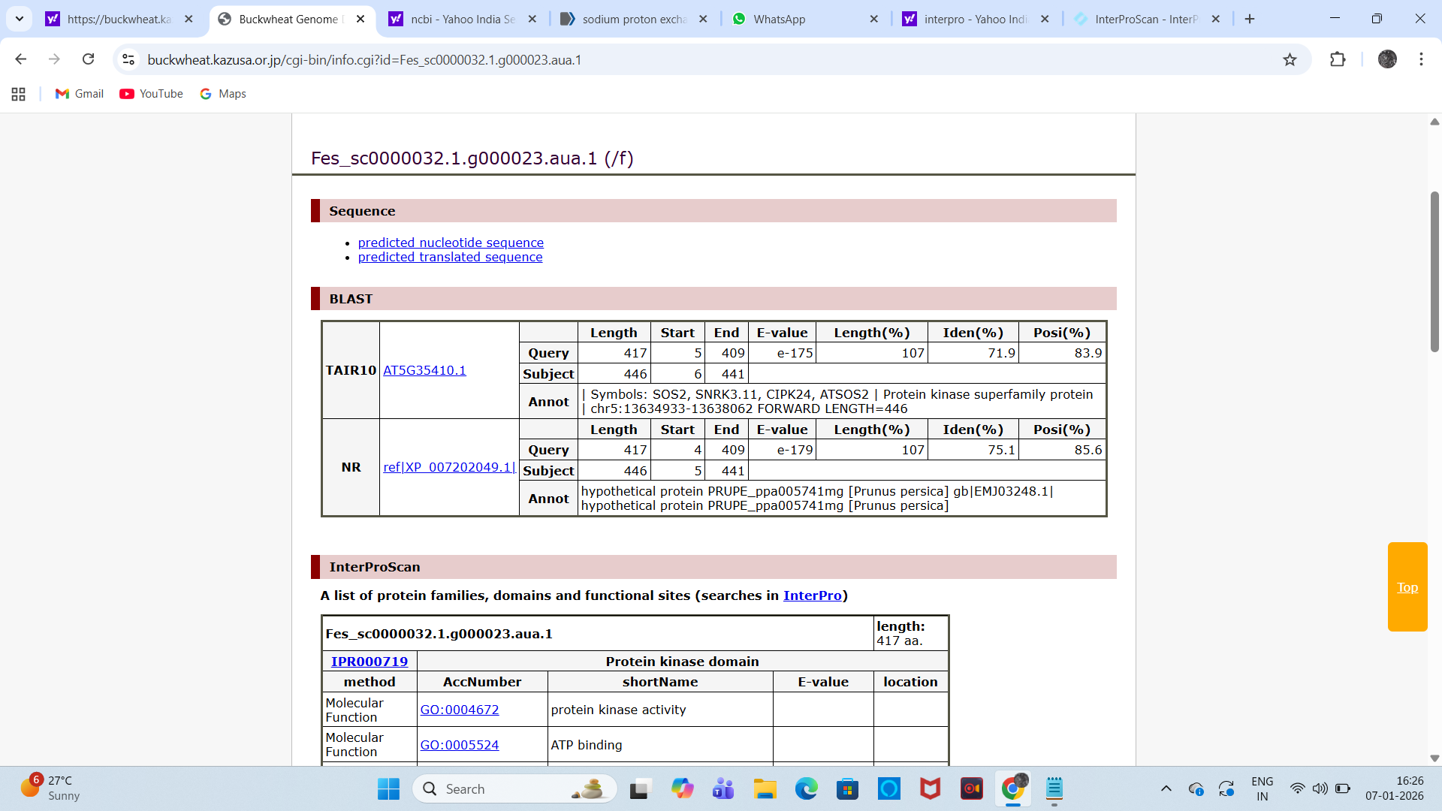
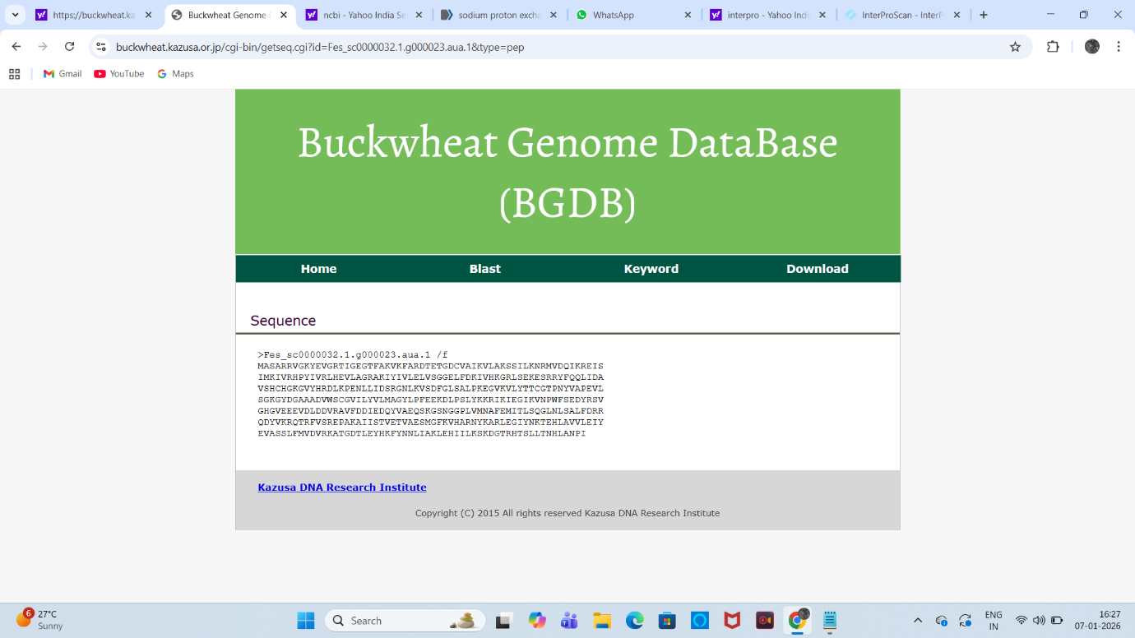

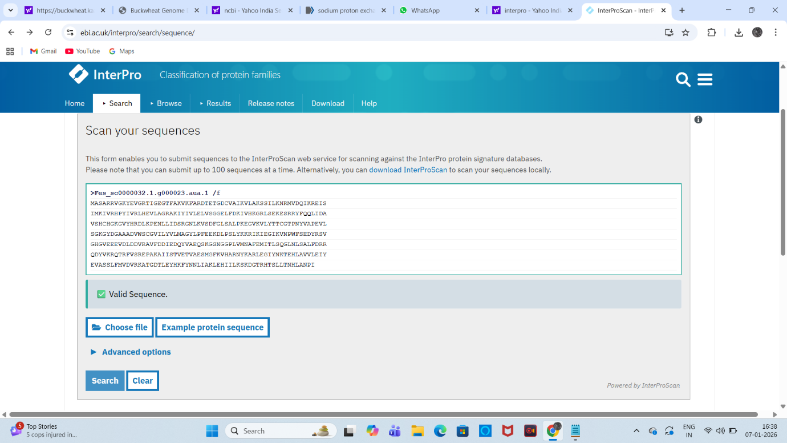

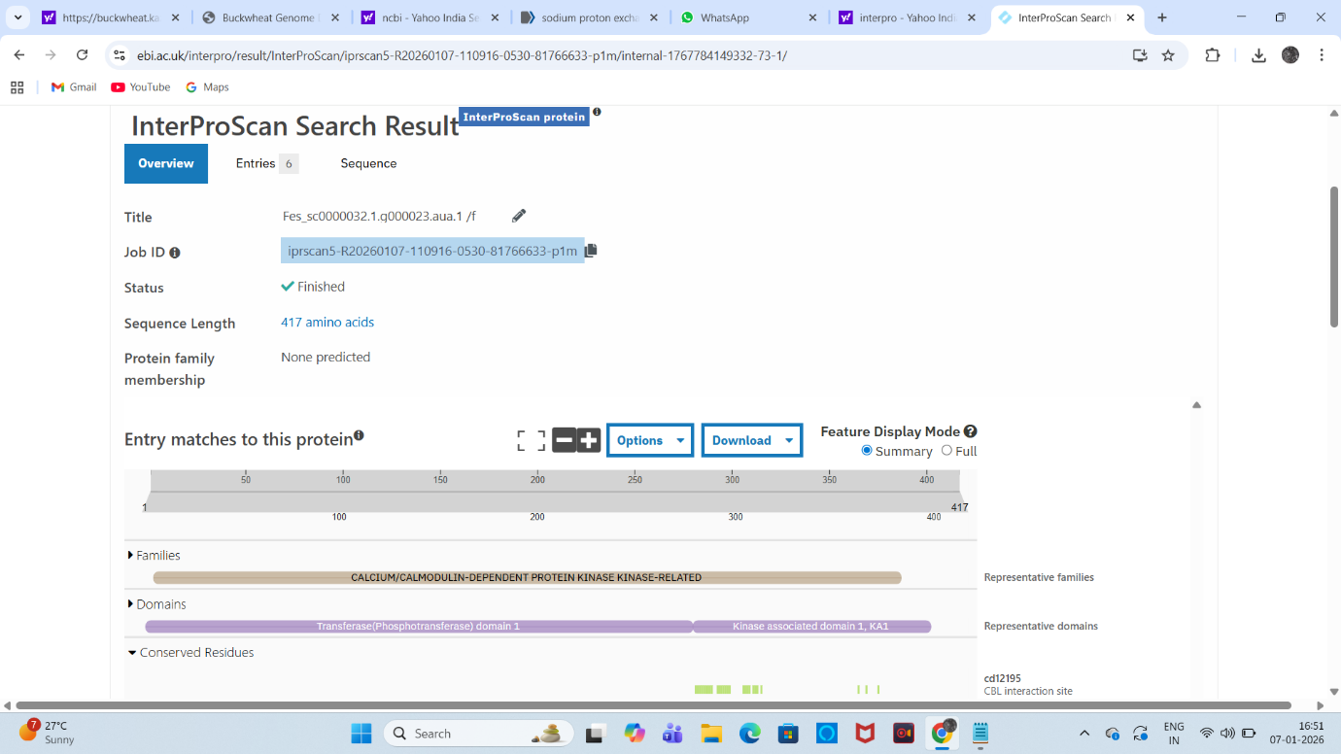
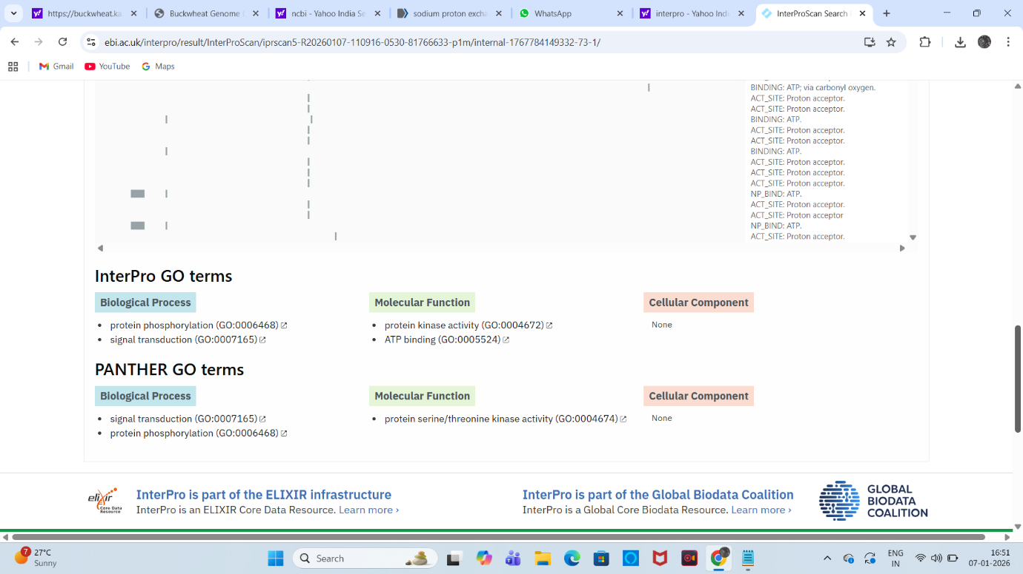

Conserved domains were identified, including serine/threonine protein kinase activity, ATP-binding sites, and a kinase-associated KA1 domain. Gene Ontology (GO) terms associated with this protein included protein phosphorylation (GO:0006468), signal transduction (GO:0007165), protein serine/threonine kinase activity (GO:0004672), and ATP binding (GO:0005524), consistent with functional SOS2 kinases.
These results confirm that Fes_sc0000032.1.9000023.aua.1 is a bonafide SOS2 homolog in buckwheat, while the remaining hits were classified as SOS2-like CIPK family members.
S.No | Buckwheat Protein ID | % Identity | E-value | Alignment Length (aa) | Classification
01. | Fes_sc0000032.1.9000023.aua.1 | 69% | 0.0 | 436 | SOS2 (canonical)
02. | Fes_ac0000024.1.0000006.aua.1 | 63% | 0.0 | 438 | SOS2-like
03. | Fes_sc0001750.1.0000005.aua.1 | 62% | 0.0 | 445 | SOS2-like
04. | Fes_ac0007348.1.0000004.aua.1 | 58% | 0.0 | 438 | SOS2-like
05. | Fes_ec0004187.1.0000004.aua.1 | 57% | 0.0 | 444 | SOS2-like
06. | Fes_ac0000499.1.0000001.aua.1 | 59% | 0.0 | 427 | SOS2-like

